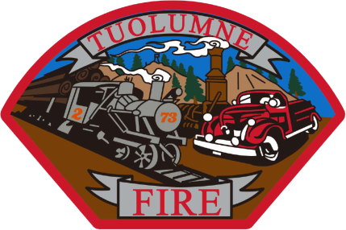

**Tuolumne Fire District**

18690 Main Street

Tuolumne, CA 95379

May 2025 Department Report

* May 1st Attended a meeting with the Strategic Planning Committee and Tuolumne Band Of Me Wuk Indians.
* May 2nd Donated surplus SCBA’s equipment picked up for Mexico.
* May 4th Held a Meet and Greet hiring event at the station for new intern firefighters. Hired two.
* May 6th On duty crew attended an MCI medical training with Black Oak Casino medical staff.
* May 14th Hired one additional Intern FF from the recent Columbia College Fire Academy.
* May 15th Attended Chief’s meeting virtually from the station.
* May 16th On duty crew did fireworks standby at Black Oak Casino.
* May 17th On duty crew did medical standby for Luc’s Run in Tuolumne.
* May 18th Annual hose testing has been started.
* May 20th On duty crew did training with PHI Med-42 helicopter at Westside for Summerville High School.
* May 30th On duty crew attended Memorial Day Veterans event at Carter’s Cemetery.

Please contact me with any questions or concerns.

Respectfully,

Jeff Santi

Fire Chief