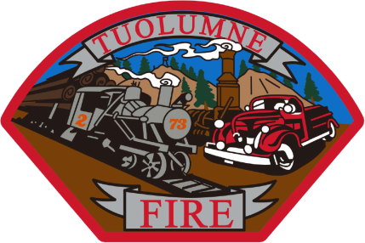

**Tuolumne Fire District**

18690 Main Street

Tuolumne, CA 95379

August 2025 Department Report

* August 5th On duty crew attended EMS training at Elevate.
* August 7th New propane tank was inspected per SDRMA requirements.
* August 10th E-732 not running right. Taken out of service by Engineer DeGraff.
* August 12th On duty crew attended EMS training at Elevate.
* August 12th Started to diagnose E-732 issue. #6 cylinder not firing. Waiting for repair approval.
* August 14th On duty crew attended EMS training at station 81.
* August 20th On duty crew attended pool safety training at BOC resort.
* August 27th On duty crew attended pool safety training at BOC resort.
* August 30th Started the tear down of E-732 engine with approval for warranty work by George Danicourt.

Please contact me with any questions or concerns.

Respectfully,

Jeff Santi

Fire Chief